**Get the AAVANTO advantage**



Conceptual clarity  
through visualisation

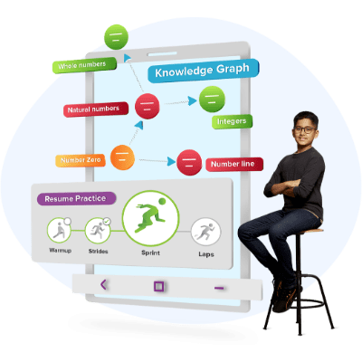

Personalised learning  
programs



Unmatched individual  
attention

**needs**

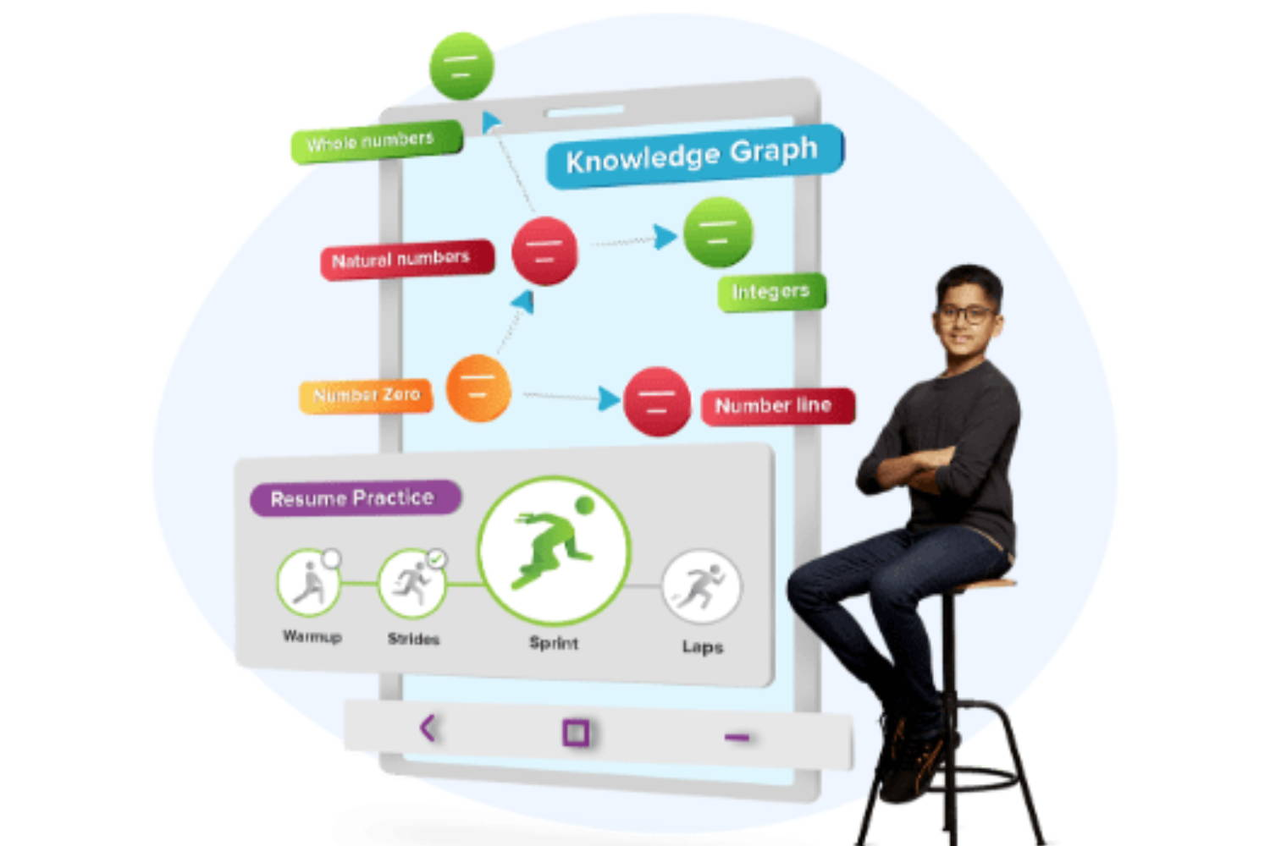

**Exam Preparation**

### LIVE AAVANTO Classes Online tuitions for complete doubt resolution because

## 0% Doubts = 100% Learning



#### Learn from 2 teachers in 1 class

•  Concepts taught by expert teachers using high-quality video lessons with rich visuals  
•  A class teacher provides personal attention and makes the class interactive

ADD SOME MORE CONTENT ARSHAD



#### Clarify doubts in-class or post-class

• Effective in-class doubt resolution by class teacher and LIVE, in-chat feature to get doubts solved by teachers anytime, anywhere after class.